**ParkEase – Smart Parking Spot Finder**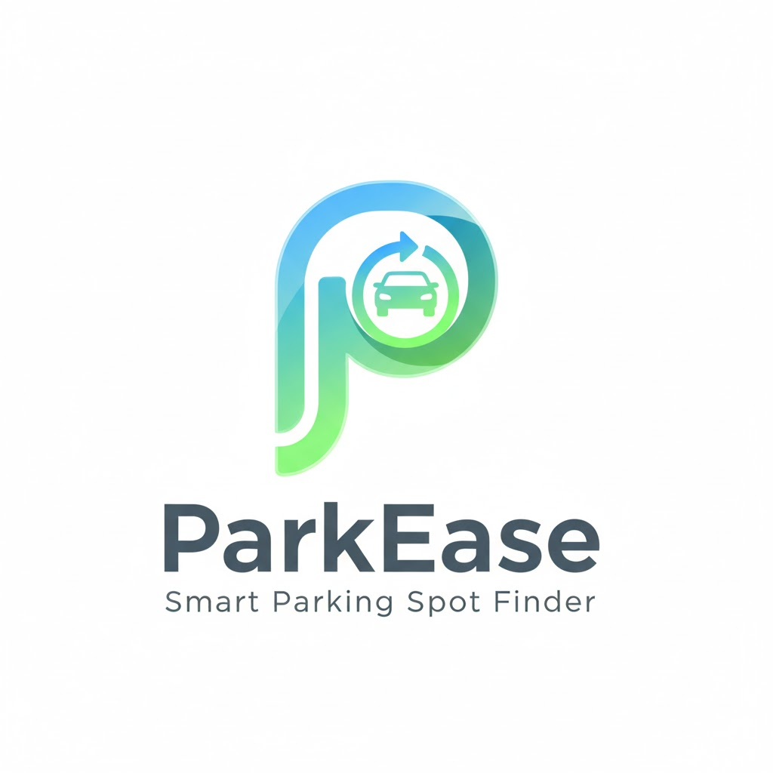

# **Introduction**

ParkEase – Smart Parking Spot Finder is an intelligent parking management system designed to help drivers locate available parking spaces in real time using smart technologies.

With rapid urbanization and increasing vehicle population, parking has become one of the major challenges in modern cities. Drivers often spend significant time searching for vacant parking spots, especially in crowded areas such as malls, hospitals, offices, and educational institutions.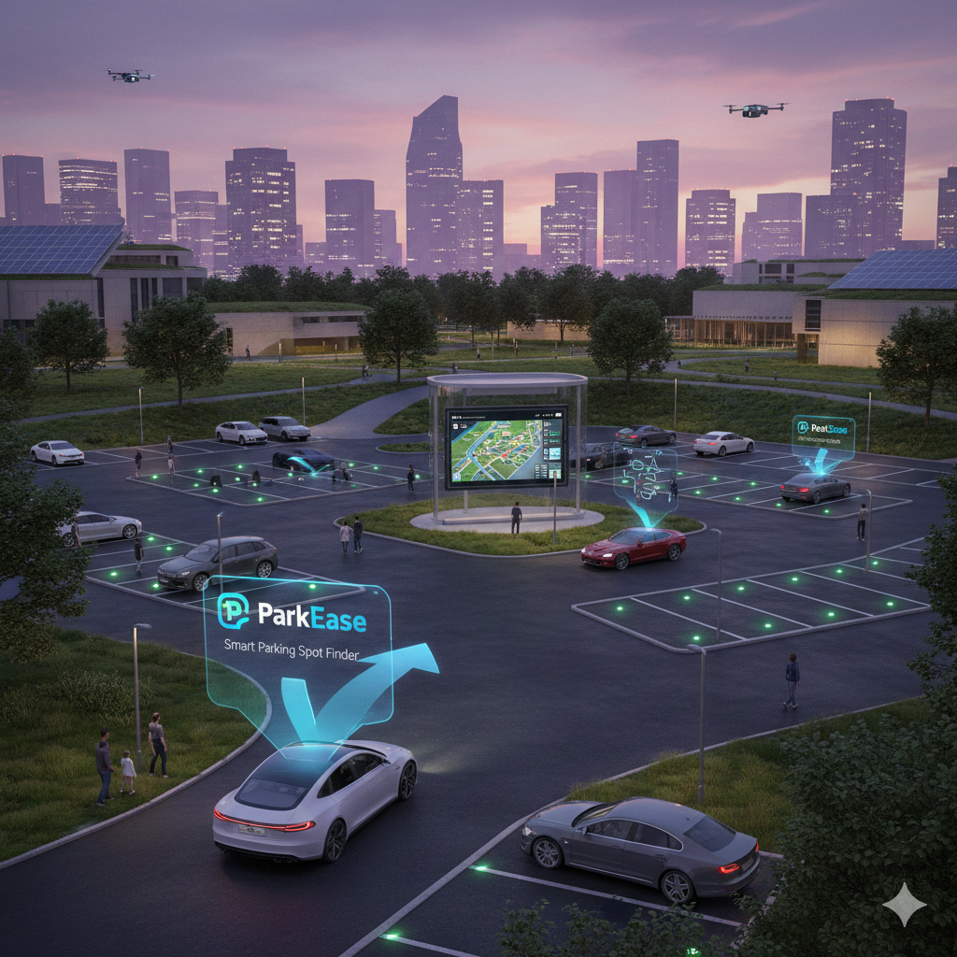

This project aims to solve this problem by developing a smart system that detects parking slot availability and displays it to users through a digital platform.

The system uses modern technologies such as sensors, cloud servers, and mobile/web applications to provide accurate parking information. ParkEase contributes toward building smarter cities by improving parking efficiency and user convenience.

# **Problem Statement**

With rapid urbanization and increasing vehicle ownership, parking management has become a significant challenge in modern cities. In most public places such as shopping malls, hospitals, offices, and educational institutions, parking systems are still manual or poorly organized. Drivers are forced to search for vacant parking spaces by driving around parking areas, which consumes time and causes inconvenience.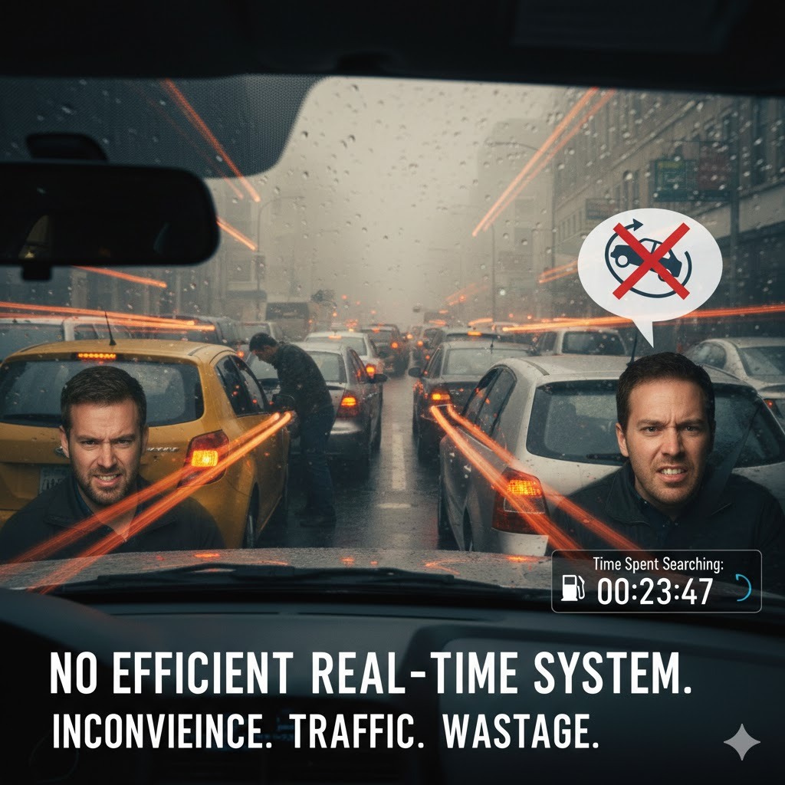

A major issue is the absence of real-time information about parking slot availability. As a result, drivers often spend several minutes searching for a free spot, leading to unnecessary traffic congestion within parking premises. This continuous vehicle movement increases fuel consumption and contributes to environmental pollution. Additionally, improper parking due to lack of guidance can create safety concerns and block access routes.

From a management perspective, traditional parking systems offer limited monitoring and control. Parking authorities lack accurate data regarding slot usage and peak hours, making efficient space utilization difficult.

### Therefore, the core problem is:

*There is no automated, real-time parking guidance system to help drivers easily locate available parking spaces, resulting in time wastage, fuel loss, traffic congestion, and inefficient parking management.*

This highlights the need for a smart parking solution that can provide live parking information and improve both user convenience and parking efficiency.

# **Objectives of the Project**

The primary objectives of ParkEase are:

* To provide real-time parking slot availability  
  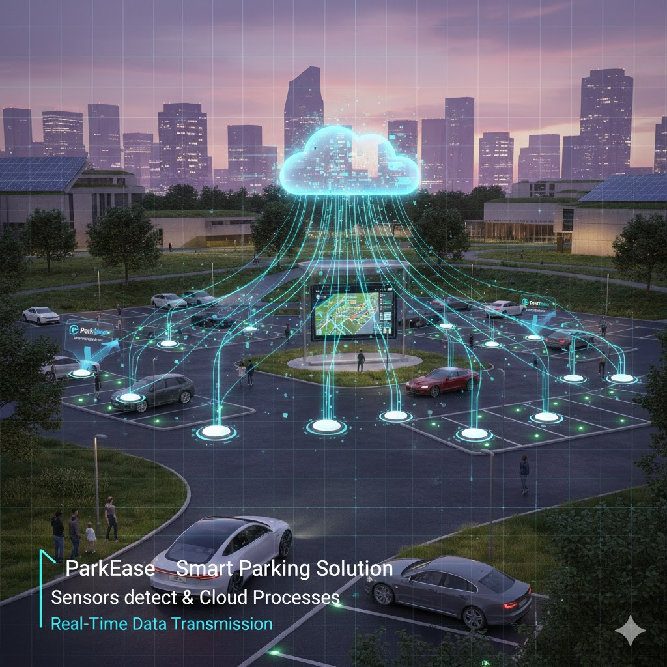
* To reduce parking search time
* To minimize traffic congestion
* To save fuel and energy
* To improve user experience
* To enable efficient parking management
* To support smart city development

# **Proposed Solution / Approach**

ParkEase provides a digital solution where parking slots are monitored automatically using sensors or cameras.

### Working Approach:

1. Sensors detect vehicle presence in parking slots
2. Data is transmitted to cloud server
3. Server processes availability information
4. Mobile/Web application displays real-time status

# **Scope of the Project**

The scope of the *ParkEase – Smart Parking Spot Finder* project focuses on developing an intelligent parking management system that provides real-time information about parking availability and improves the overall parking experience for users as well as administrators.

This project aims to design a digital platform where parking slots are automatically monitored and their status is displayed to users through a mobile or web interface. The system helps drivers locate vacant parking spaces quickly, reducing unnecessary movement inside parking areas and improving traffic flow.

### Current Scope:

* Real-time monitoring of parking slot occupancy
* User interface to display available parking spaces
* Navigation assistance to guide users to free slots
* Administrative dashboard for parking management  
  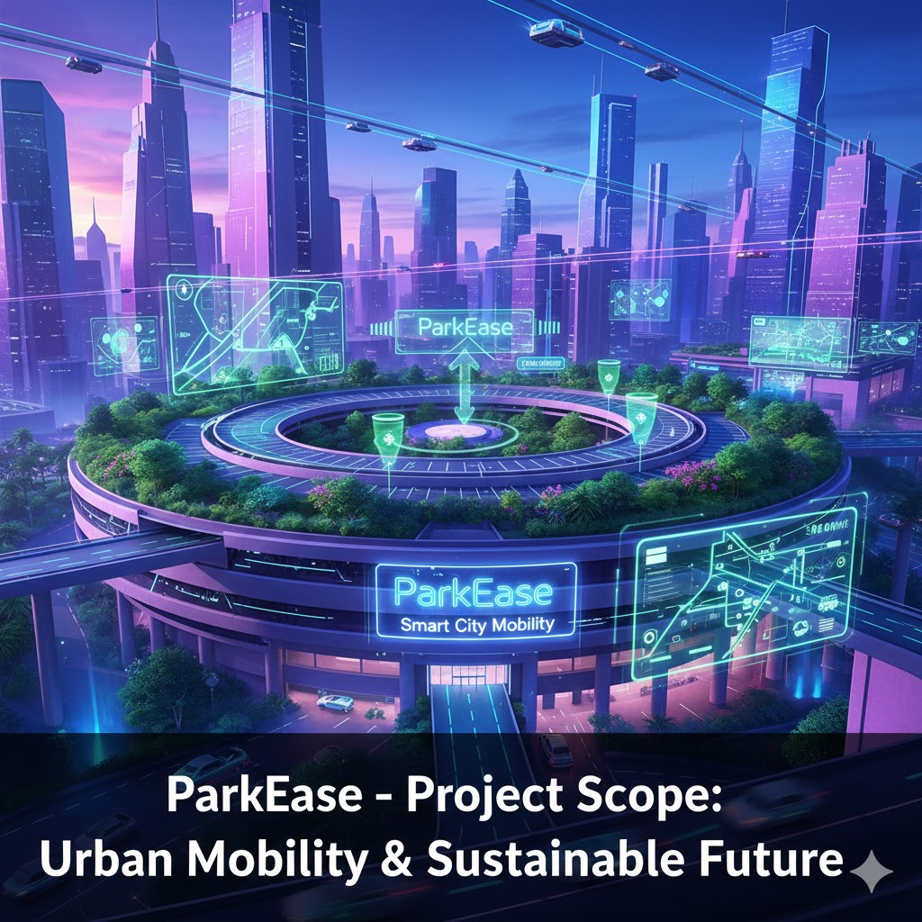
* Basic data collection and usage analytics

### **Future Scope:**

* Online parking slot reservation
* Digital payment integration
* AI-based parking availability prediction

In the future, ParkEase can be expanded into a fully automated smart parking ecosystem supporting advanced analytics, cashless payments, and intelligent traffic management. This makes the project scalable and suitable for real-world deployment in smart cities.

**Project Approach**

The ParkEase – Smart Parking Spot Finder project will be developed using a systematic and modular approach to ensure clarity, scalability, and practical implementation. The project focuses on providing real-time parking availability through a digital platform.

1. **Requirement Analysis** First, we will analyze the parking problem and identify system requirements such as number of parking slots, user interface needs, and administrative features.
2. **System Design** A basic architecture will be designed consisting of parking slots, sensing mechanism, server/cloud, and a mobile or web application. This design defines how data flows from parking slots to users.
3. **Slot Detection Module** Parking slots will be monitored using sensors or simulated inputs to determine whether a slot is occupied or vacant.
4. **Backend Development** A server will be created to receive parking data, process it, and store it in a database. This backend will manage real-time slot updates.
5. **Frontend Development** A user-friendly interface will be developed where users can view available parking spaces and get navigation assistance.
6. **Admin Dashboard** An administrative panel will be implemented to monitor parking usage, slot status, and system performance.
7. **Testing and Validation** The system will be tested under different scenarios to ensure accurate slot detection and smooth user experience.
8. **Deployment and Documentation** Finally, the project will be deployed in a basic environment and documented for demonstration and future enhancement.

## **Applications of ParkEase Smart Parking Spot Finder**

ParkEase can be implemented in various real-life environments where parking management is critical: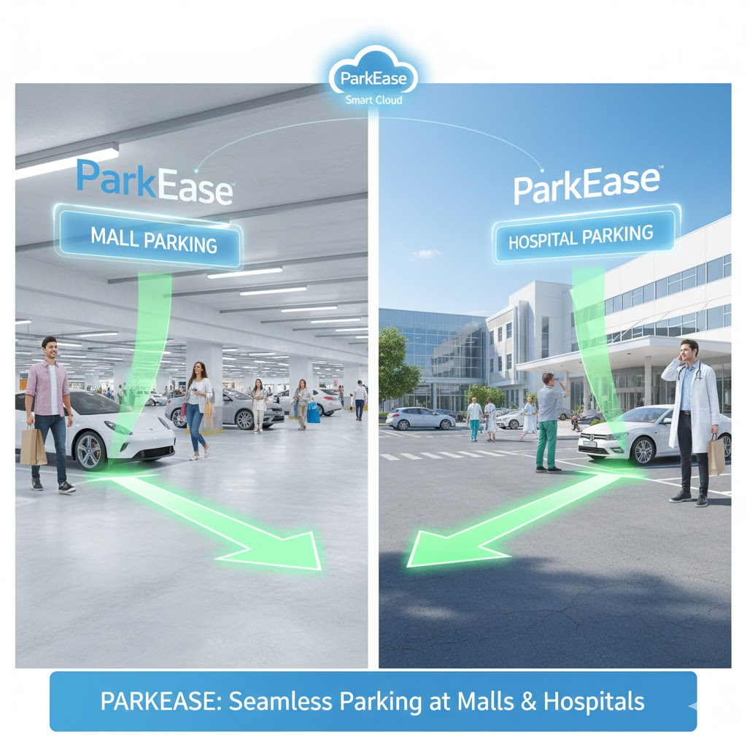

* Shopping malls
* Hospitals
* Airports
* Railway stations
* Colleges and universities
* Office complexes
* Smart cities

In these locations, ParkEase helps drivers quickly locate available parking slots, reduces congestion, and improves overall traffic flow. For administrators, it provides better monitoring, efficient space utilization, and valuable data insights. With future enhancements such as online booking, digital payments, and AI-based predictions, ParkEase can evolve into a complete smart parking ecosystem supporting intelligent urban infrastructure.

# **Conclusion**

ParkEase – Smart Parking Spot Finder provides an effective solution to modern parking problems. By integrating smart sensing technologies with digital platforms, it enables real-time parking guidance and improves overall urban mobility.

ParkEase represents a significant step toward intelligent transportation systems and smart city infrastructure.